**WEEK-3**

Create Index.html and style.css pages----

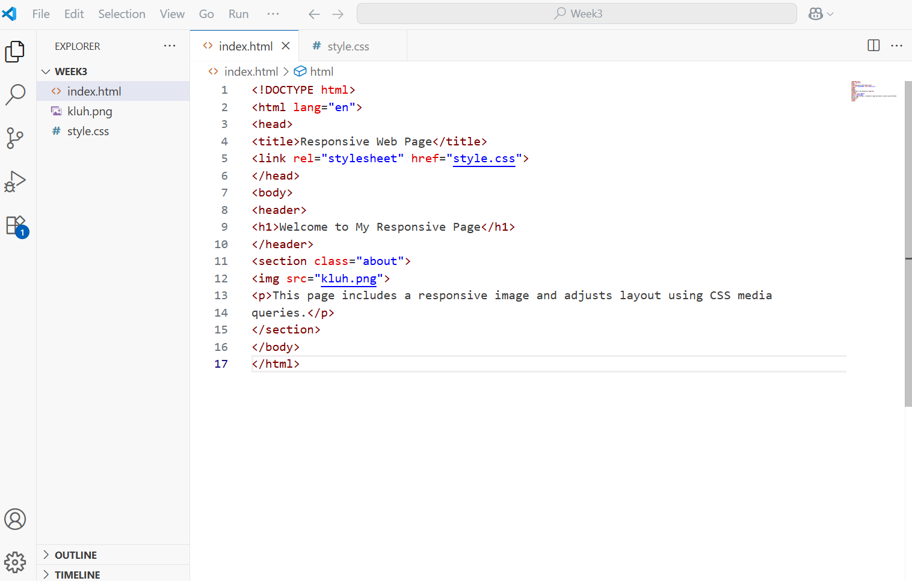

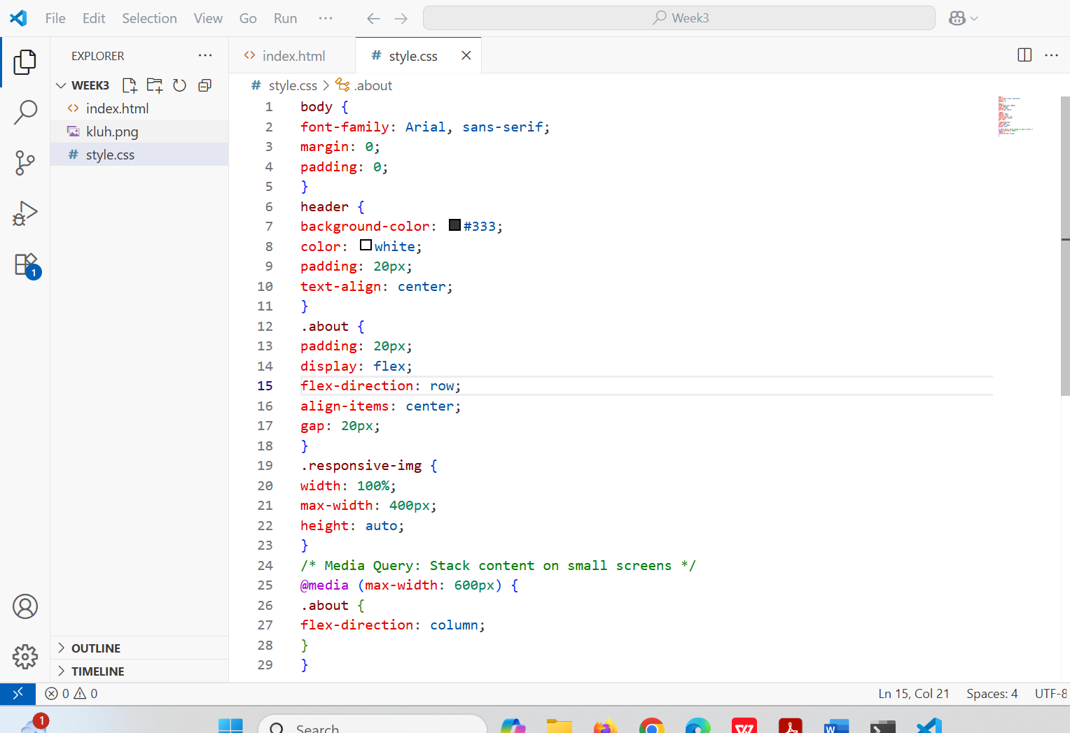

Click on GoLive:

Output:

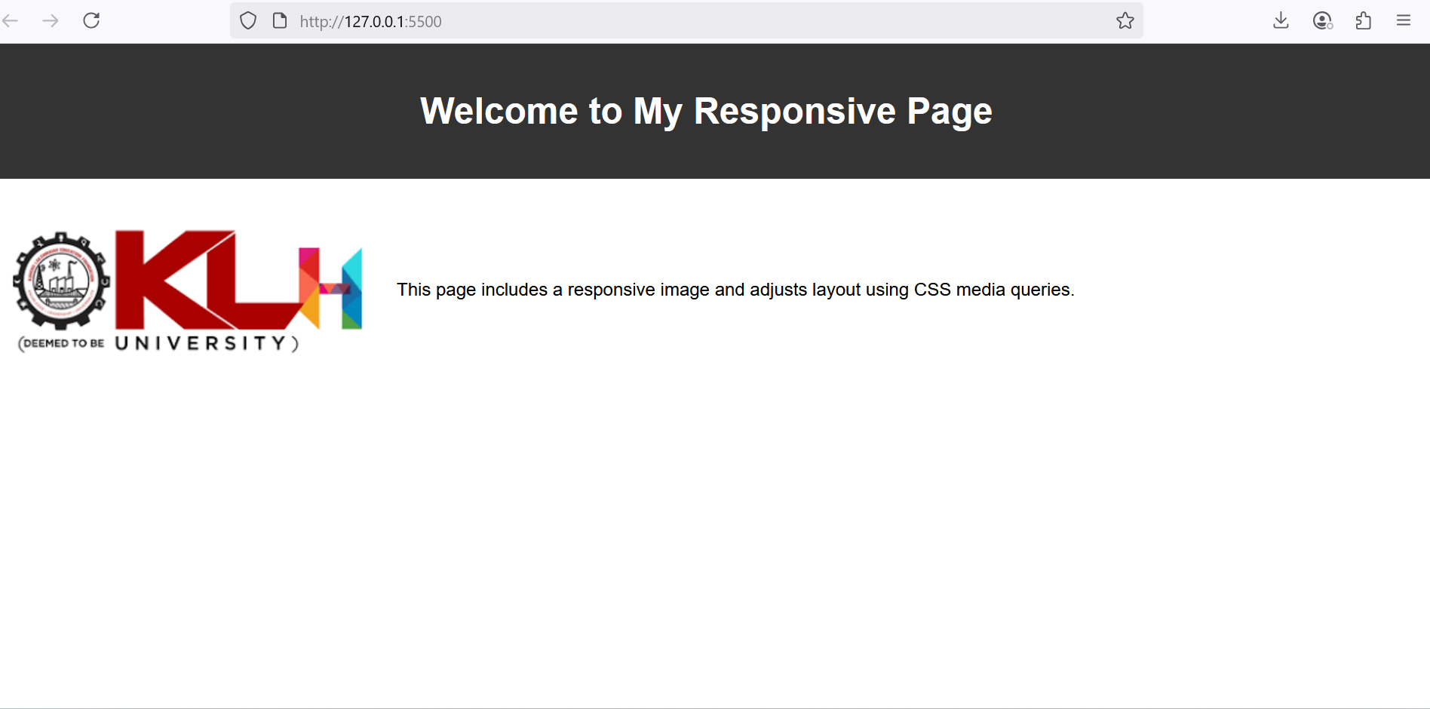

Open New Terminal:

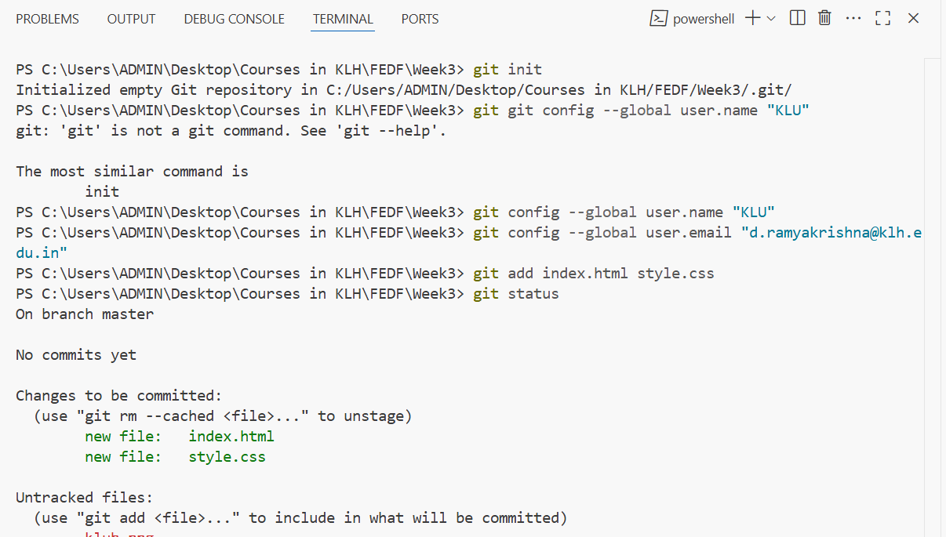

Commit the changes:

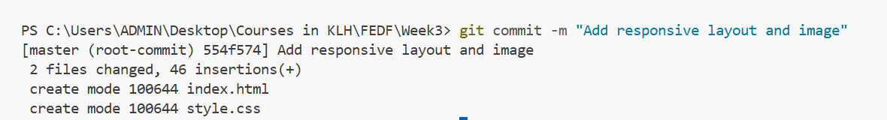

Check the log:

git log is a command in Git used to **view the commit history** of your repository. It shows information about each commit, such as:

* The **commit hash** (unique ID of the commit)
* The **author** of the commit
* The **date** when the commit was made
* The **commit message**

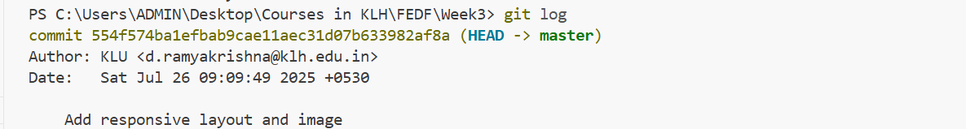

The git diff command is used to **show changes** between:

1. **Working directory and staging area**
2. **Staging area and the last commit**
3. **Two commits**
4. **Two branches**
5. **Two files**

PS C:\Users\ADMIN\Desktop\Courses in KLH\FEDF\Week3> git diff

|  |  |
| --- | --- |
| git checkout -- file | Discards **unstaged changes** in working directory |

|  |  |
| --- | --- |
| git reset HEAD file | Unstages file (keeps changes in working directory) |



Keep some changes in the file index.html:

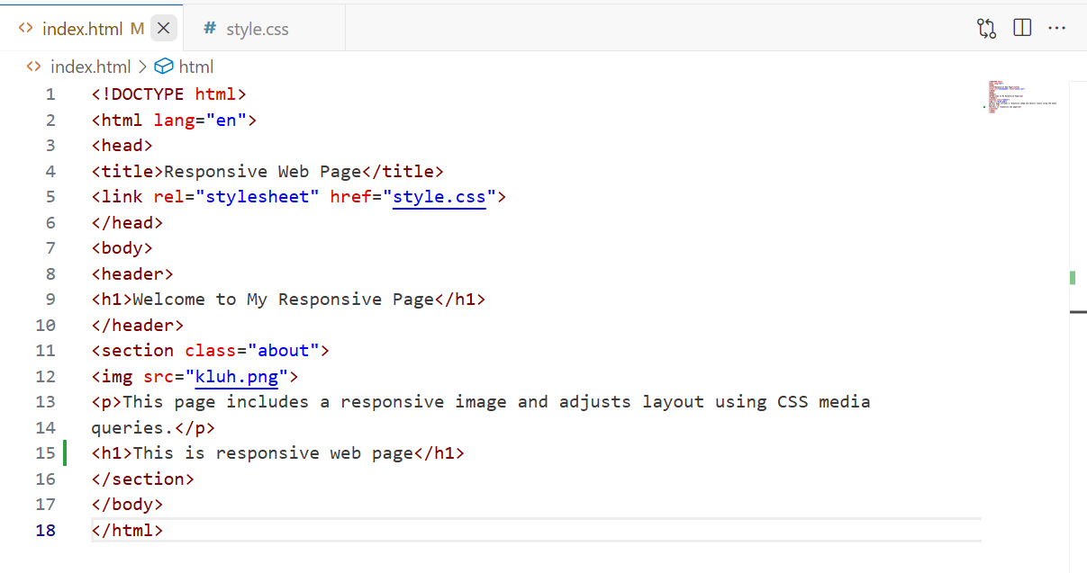

Now, again check git diff command:

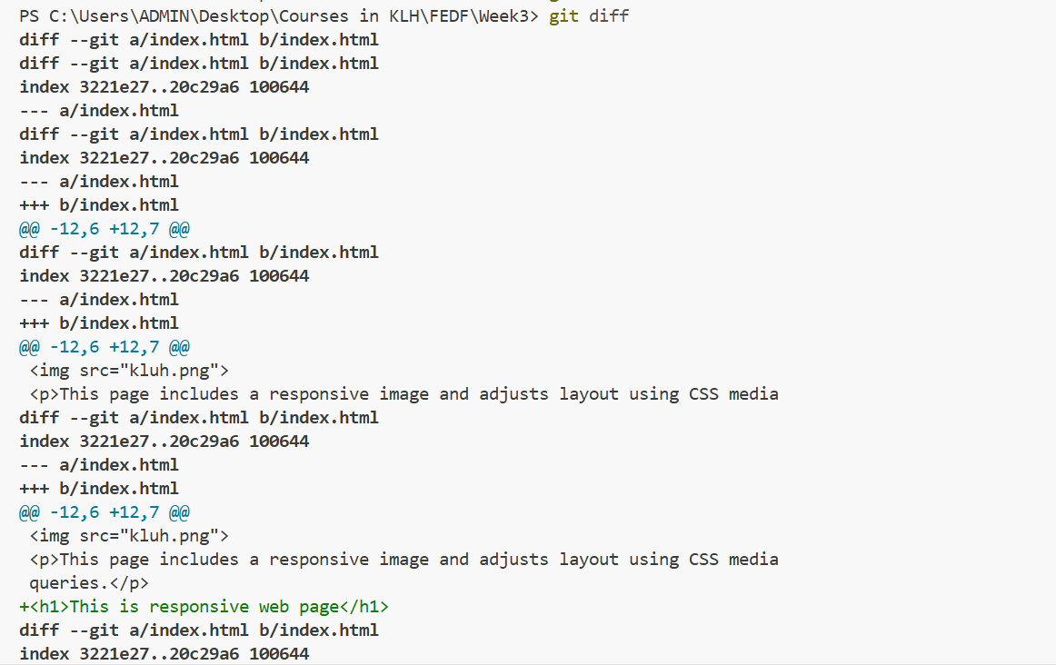

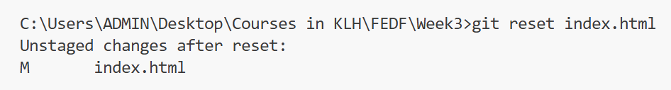

Push to github:



If you get error, while using push command directly, use these commands:

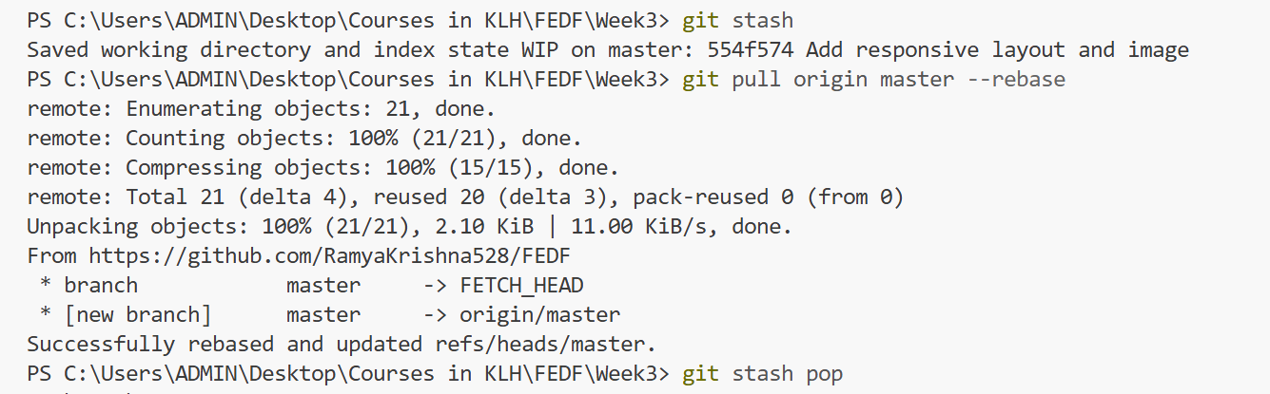

Later use push command:

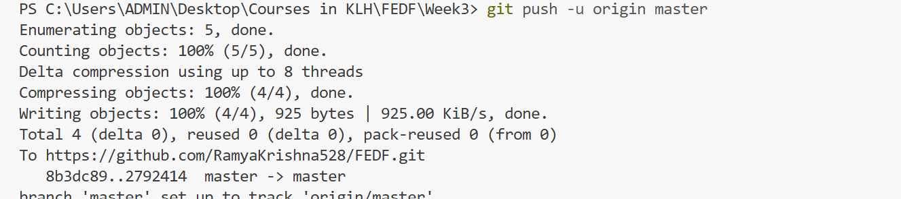

If you want to push the image also:

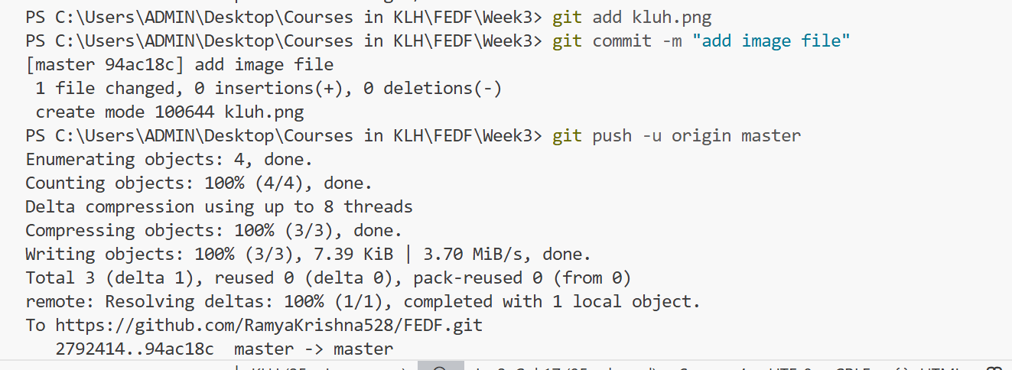

In Github, how to view pages in Live?

1. Go to your GitHub repo
2. Click on the **⚙️ Settings** tab (at the top of the repo).
3. In the left sidebar, scroll down and click **Pages** (or under **“Pages and Wikis” > “Pages”**).
4. Under **“Source”**, choose:

**Branch**: master

**Folder**: / (root)

1. Under the **GitHub Pages** section, you’ll see something like this:

**Your site is live at:**

Output:

